Spherical Solids of Revolution

Definition
# Source: AI Source: Provided by: [Data Path: Persons Table -> ID Column: 1, Name_En Column: Motasem Essam] -> From: [ChatGPT] on [7/25/2026]
Spherical Solids of Revolution are three-dimensional solids generated by rotating suitable circular or semicircular plane regions around a straight axis in their plane.
The principal example is the solid sphere, generated by rotating a semicircular region around its diameter through a complete revolution of ${360}^{∘}$.
The rotation produces a spherical solid whose surface consists of all points at an equal distance from a fixed center.
Other spherical forms, such as spherical segments and spherical sectors, can be generated by rotating portions of circular regions around suitable axes.

Geometric Representation
# Source: AI Source: Provided by: [Data Path: Persons Table -> ID Column: 1, Name_En Column: Motasem Essam] -> From: [ChatGPT] on [7/25/2026]
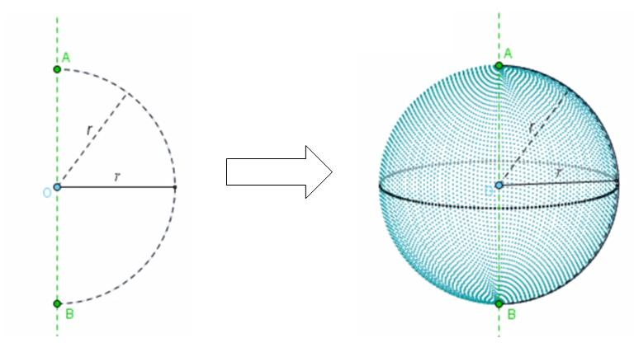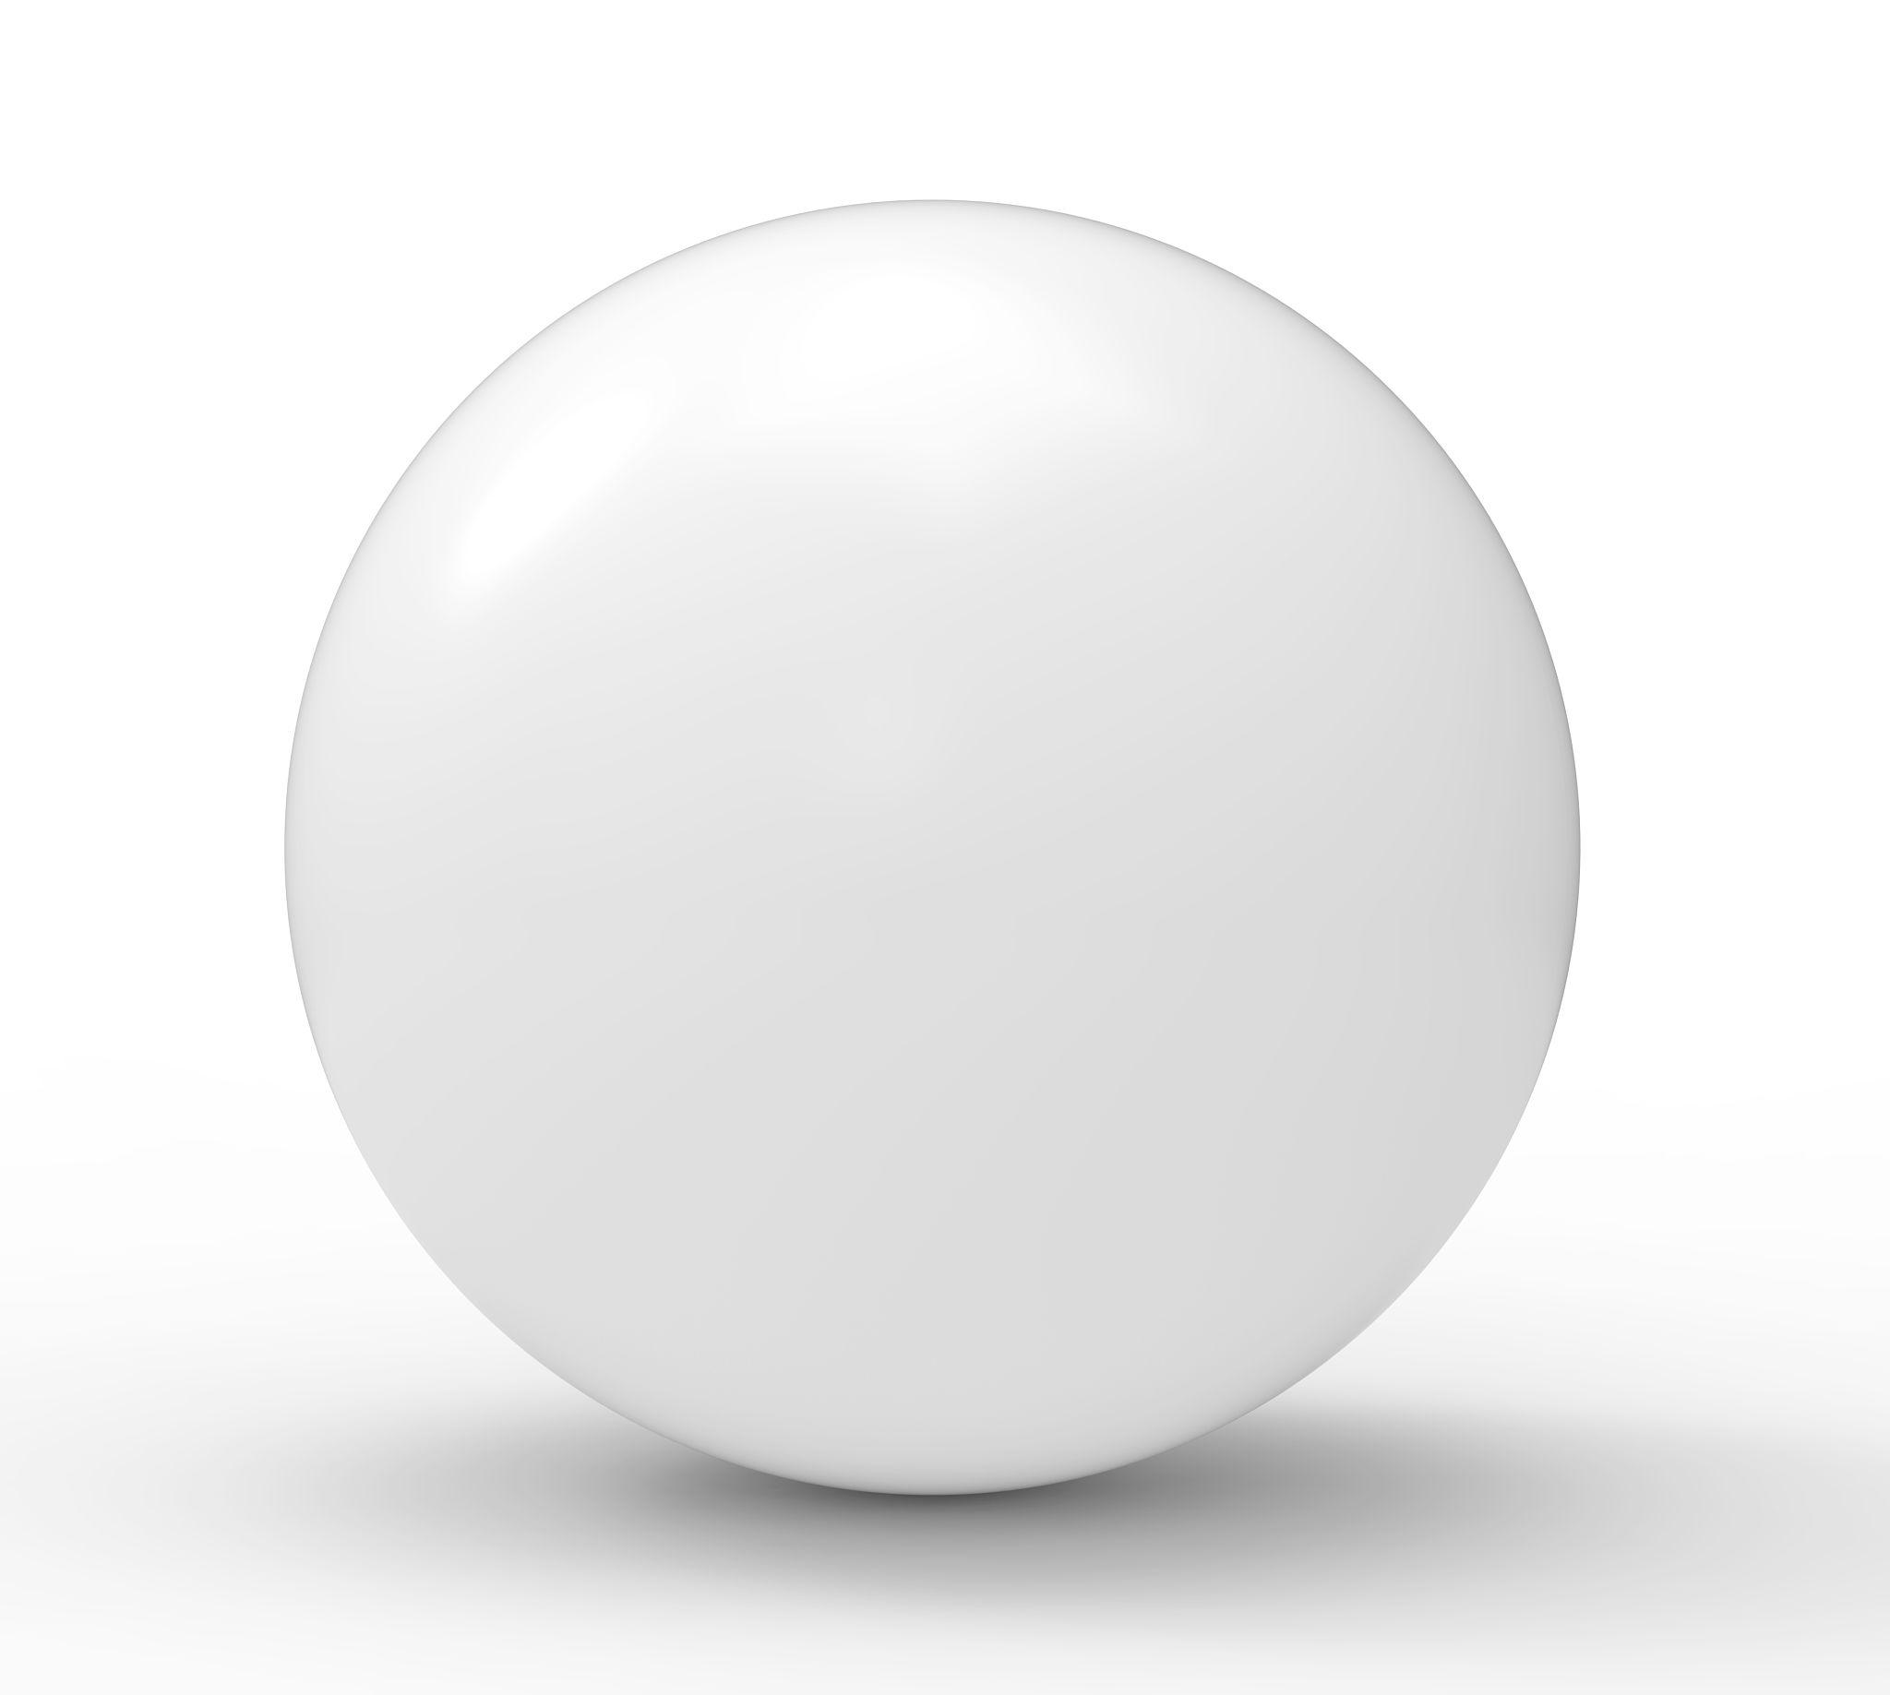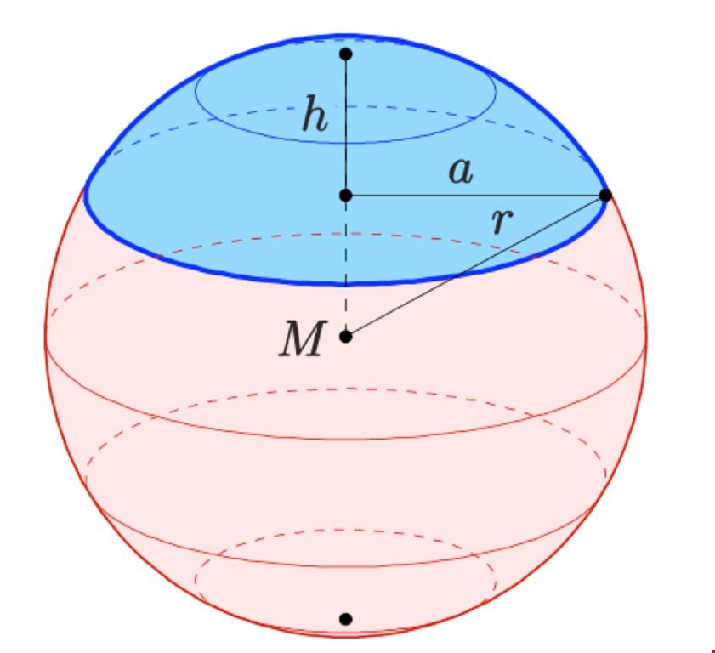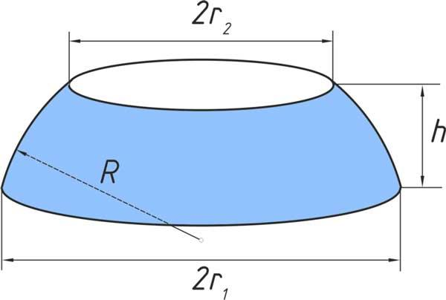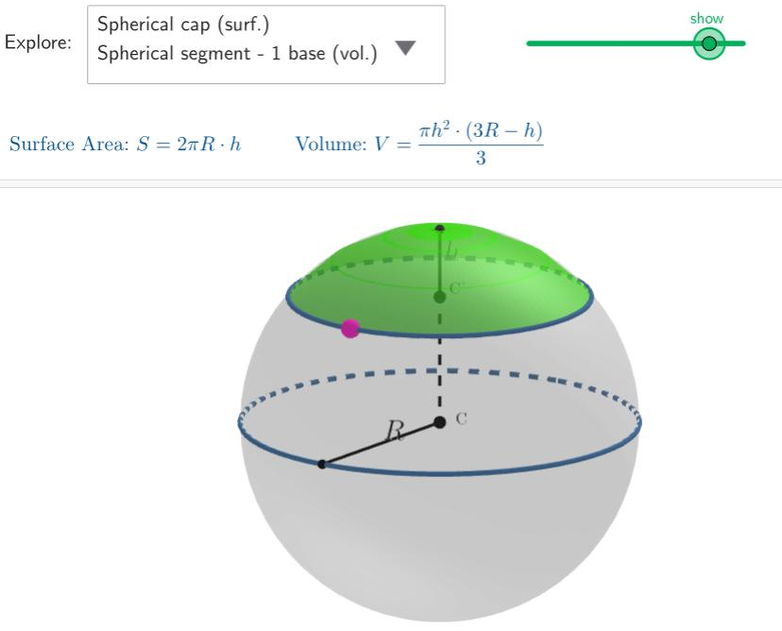
The generating region determines the resulting spherical solid:
- Semicircular region rotated around its diameter → sphere.
- Circular region rotated around a diameter → sphere.
- Partial semicircular region rotated around the same diameter → spherical sector.
- A suitable portion of a circular region rotated around an axis can generate other spherical solids or portions of spherical solids.
Important distinction: A semicircular region is a filled half-disk, whereas a semicircular arc is only its curved boundary. Rotating the filled region generates the sphere's volume; rotating the arc generates the spherical surface.

Geometric Structure
# Source: AI Source: Provided by: [Data Path: Persons Table -> ID Column: 1, Name_En Column: Motasem Essam] -> From: [ChatGPT] on [7/25/2026]
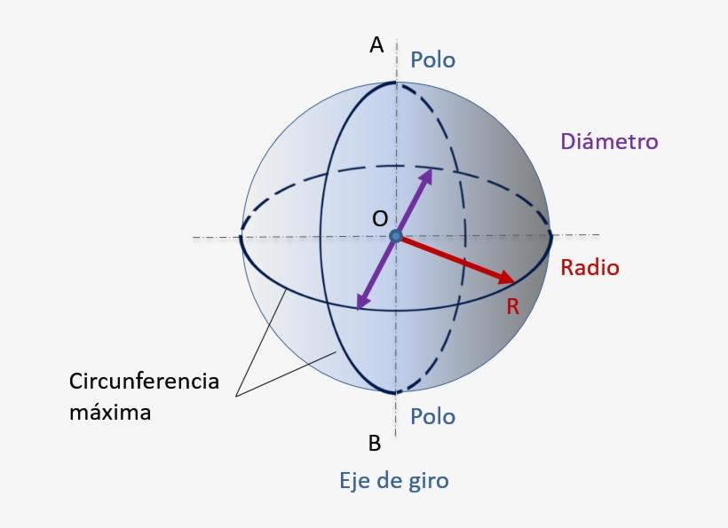
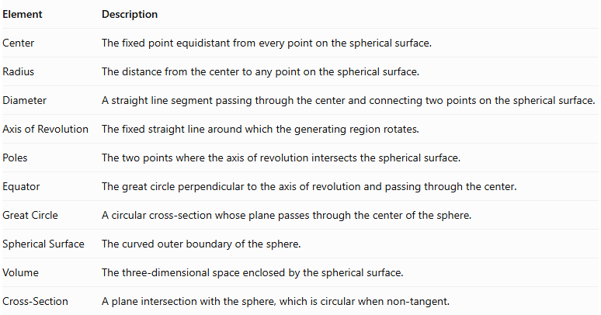
Element | Description
Center | The fixed point equidistant from every point on the spherical surface.
Radius | The distance from the center to any point on the spherical surface.
Diameter | A straight line segment passing through the center and connecting two points on the spherical surface.
Axis of Revolution | The fixed straight line around which the generating region rotates.
Poles | The two points where the axis of revolution intersects the spherical surface.
Equator | The great circle perpendicular to the axis of revolution and passing through the center.
Great Circle | A circular cross-section whose plane passes through the center of the sphere.
Spherical Surface | The curved outer boundary of the sphere.
Volume | The three-dimensional space enclosed by the spherical surface.
Cross-Section | A plane intersection with the sphere, which is circular when non-tangent.

Types of Spherical Solids of Revolution

Sphere (Solid Sphere)
# Source: AI Source: Provided by: [Data Path: Persons Table -> ID Column: 1, Name_En Column: Motasem Essam] -> From: [ChatGPT] on [7/25/2026]
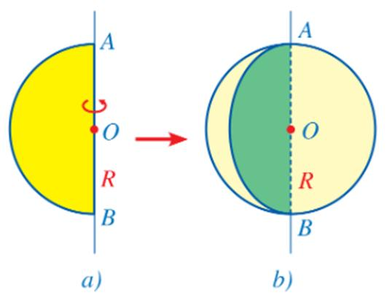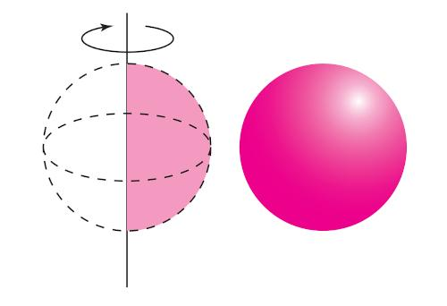
A Sphere (Solid Sphere) is generated by rotating a semicircular region around its diameter.
The rotation sweeps the entire interior volume and produces a solid with a spherical boundary.
Geometric characteristics:
- One center.
- Constant radius in every direction from the center.
- One continuous spherical surface.
- No flat faces, edges, or vertices.
- Circular cross-sections through the sphere.

Spherical Segment
# Source: AI Source: Provided by: [Data Path: Persons Table -> ID Column: 1, Name_En Column: Motasem Essam] -> From: [ChatGPT] on [7/25/2026]
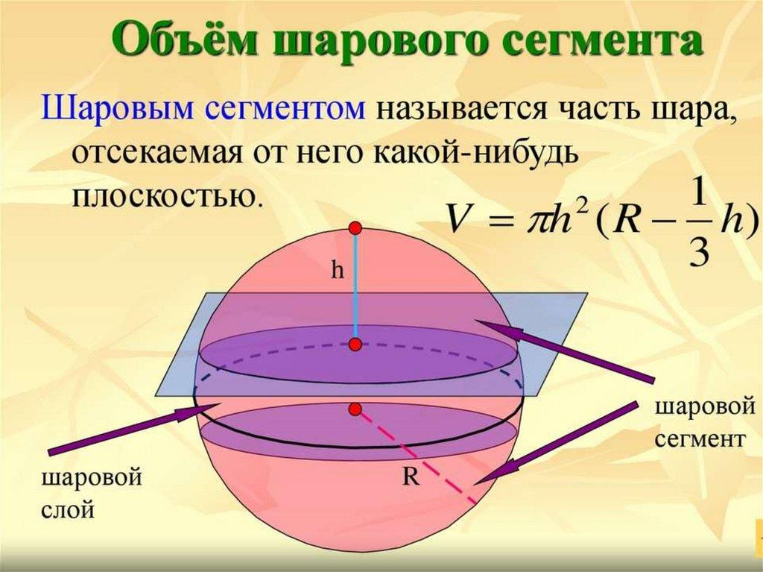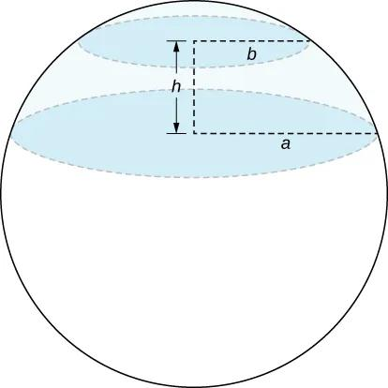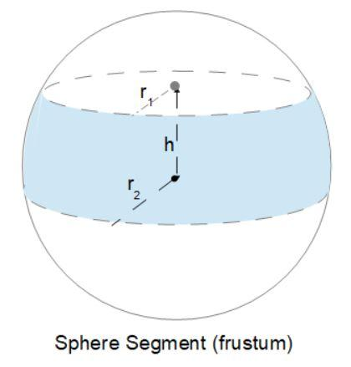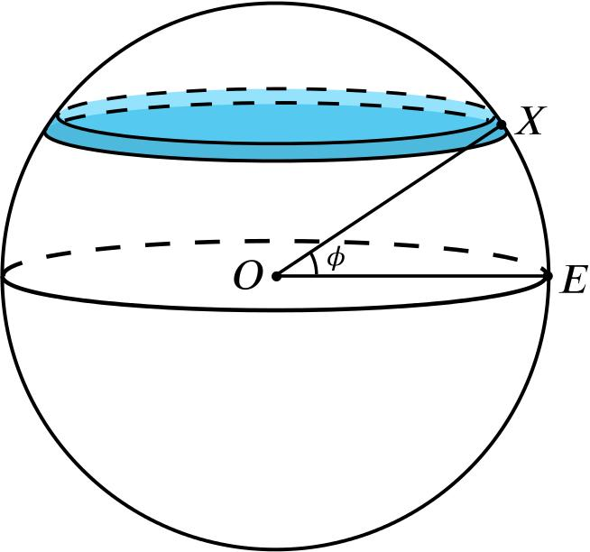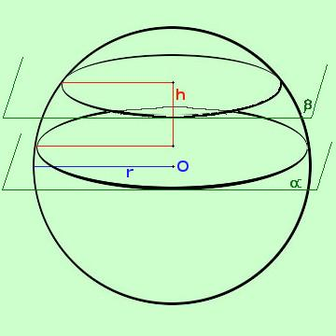
A Spherical Segment is a portion of a sphere bounded by two parallel cutting planes.
It can be generated by rotating a suitable portion of a semicircular region around its diameter.
Geometric characteristics:
- Two parallel circular bases in the usual non-degenerate case.
- One curved spherical surface.
- A height measured between the parallel base planes.
- Different upper and lower base radii in the general case.
A spherical segment with one cutting plane through a pole can reduce to a spherical cap.

Spherical Cap
# Source: AI Source: Provided by: [Data Path: Persons Table -> ID Column: 1, Name_En Column: Motasem Essam] -> From: [ChatGPT] on [7/25/2026]
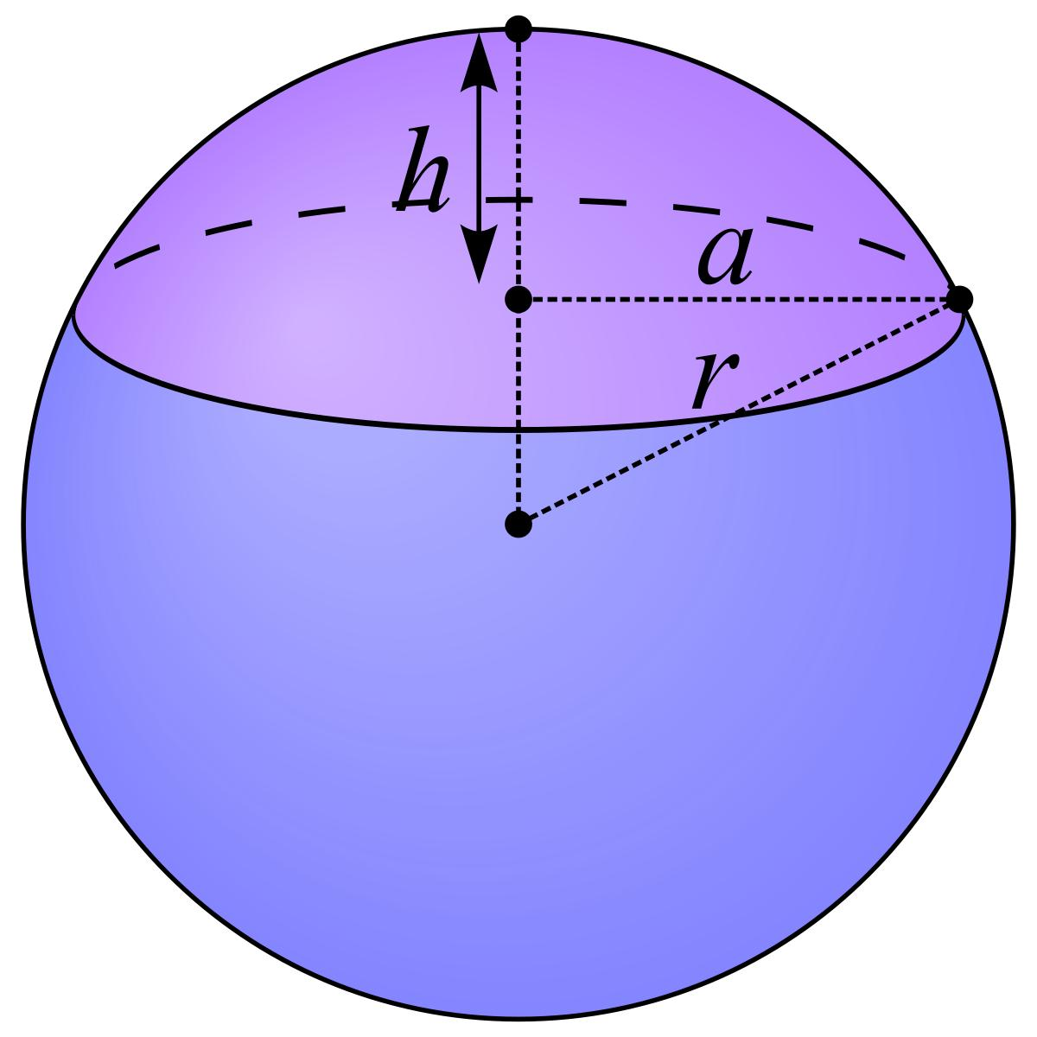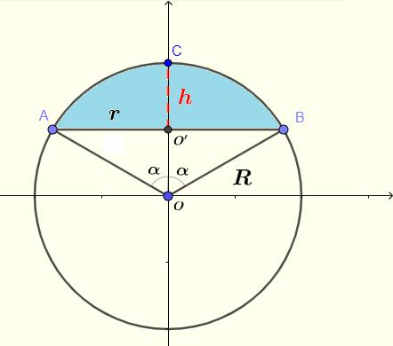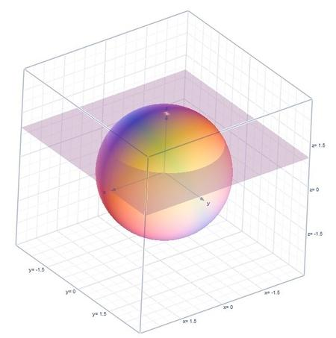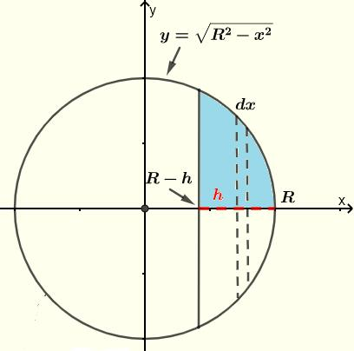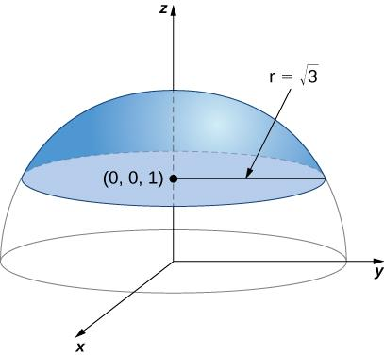
A Spherical Cap is the portion of a sphere separated from the remaining sphere by a single plane.
It is the spherical portion between a cutting plane and the nearest pole.
Geometric characteristics:
- One circular base.
- One curved spherical surface.
- One cap height.
- One base radius.
- No vertex.

Spherical Sector
# Source: AI Source: Provided by: [Data Path: Persons Table -> ID Column: 1, Name_En Column: Motasem Essam] -> From: [ChatGPT] on [7/25/2026]
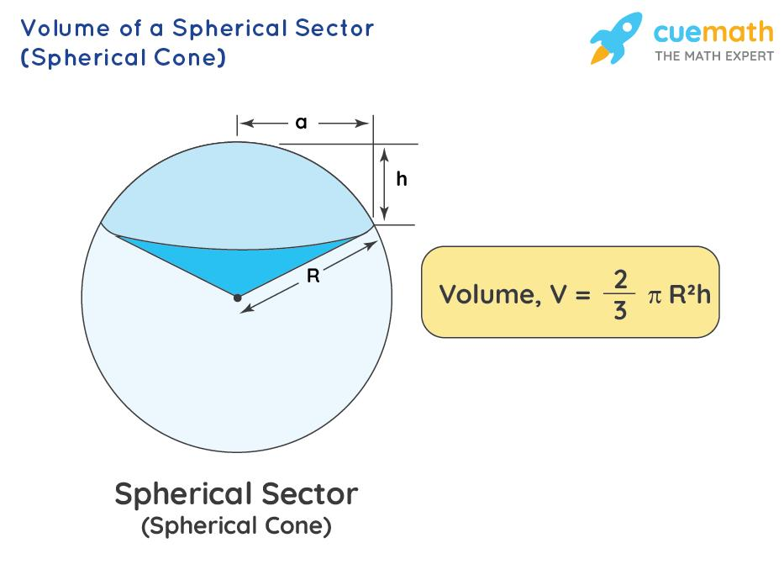
A Spherical Sector is a solid formed by rotating a sector-shaped portion of a semicircular region around the diameter of the semicircle.
It can be described as a spherical region bounded by conical surfaces and a spherical zone, depending on the selected sector.
Geometric characteristics:
- A portion of a spherical volume.
- A spherical curved boundary.
- One or more conical surfaces in its general construction.
- An axis passing through the center of the generating circle.
A complete semicircular region rotated around its diameter is the limiting full-sphere case.

Mathematical Representation

Sphere
# Source: AI Source: Provided by: [Data Path: Persons Table -> ID Column: 1, Name_En Column: Motasem Essam] -> From: [ChatGPT] on [7/25/2026]
Let:
- $R$ = sphere radius.
- $D$ = sphere diameter.
- $O$ = center of the sphere.
Diameter
$$D=2R$$
Volume
Surface Area
$$\boxed{A=4πR^{2}}$$
Great Circle Area
$$A_{g}=πR^{2}$$
Great Circle Circumference
$$C_{g}=2πR$$

Spherical Segment
# Source: AI Source: Provided by: [Data Path: Persons Table -> ID Column: 1, Name_En Column: Motasem Essam] -> From: [ChatGPT] on [7/25/2026]
Let:
- $R$ = radius of the original sphere.
- $a$ = radius of the lower base.
- $b$ = radius of the upper base.
- $h$ = distance between the two parallel base planes.
Volume
$$\boxed{V=\frac{πh}{6}(3a^{2}+3b^{2}+h^{2})}$$
Curved Surface Area
$$A_{c}=2πRh$$
Total Surface Area
$$A_{T}=2πRh+πa^{2}+πb^{2}$$
The total area includes both flat circular bases.

Spherical Cap
# Source: AI Source: Provided by: [Data Path: Persons Table -> ID Column: 1, Name_En Column: Motasem Essam] -> From: [ChatGPT] on [7/25/2026]
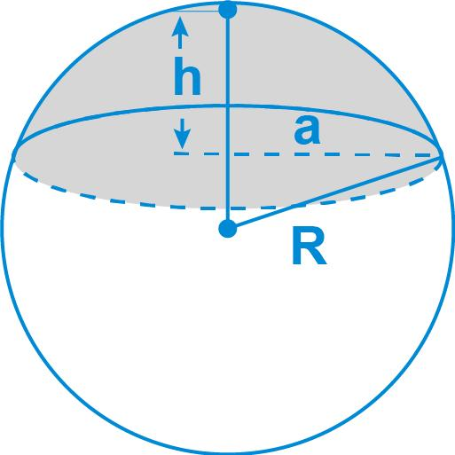
Let:
- $R$ = radius of the original sphere.
- $h$ = cap height.
- $a$ = radius of the circular base.
Base Radius
$$\boxed{a=\sqrt{2Rh-h^{2}}}$$
Volume
$$\boxed{V=\frac{πh^{2}}{3}(3R-h)}$$
Curved Surface Area
$$A_{c}=2πRh$$
Total Surface Area
$$A_{T}=2πRh+πa^{2}$$

Spherical Sector
# Source: AI Source: Provided by: [Data Path: Persons Table -> ID Column: 1, Name_En Column: Motasem Essam] -> From: [ChatGPT] on [7/25/2026]
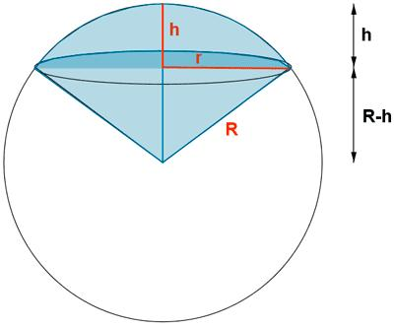
Let:
- $R$ = radius of the sphere.
- $h$ = height of the spherical zone associated with the sector.
Volume
$$\boxed{V=\frac{2}{3}πR^{2}h}$$
This is the volume formula for a spherical sector bounded by the spherical zone and the conical surface or surfaces connecting it to the sphere's center.

Mathematical Properties
# Source: AI Source: Provided by: [Data Path: Persons Table -> ID Column: 1, Name_En Column: Motasem Essam] -> From: [ChatGPT] on [7/25/2026]
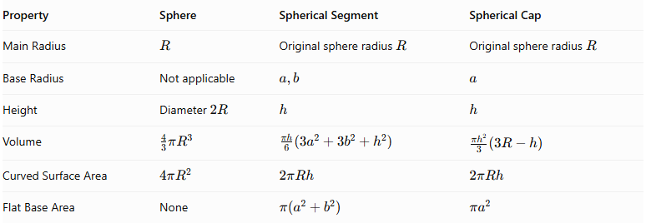
Property | Sphere | Spherical Segment | Spherical Cap
Main Radius | $$R$$ | Original sphere radius $R$ | Original sphere radius $R$
Base Radius | Not applicable | $$a,b$$ | $$a$$
Height | Diameter $2R$ | $$h$$ | $$h$$
Volume | $$\frac{4}{3}πR^{3}$$ | $$\frac{πh}{6}(3a^{2}+3b^{2}+h^{2})$$ | $$\frac{πh^{2}}{3}(3R-h)$$
Curved Surface Area | $$4πR^{2}$$ | $$2πRh$$ | $$2πRh$$
Flat Base Area | None | $$π(a^{2}+b^{2})$$ | $$πa^{2}$$

Cross-Sectional Properties
# Source: AI Source: Provided by: [Data Path: Persons Table -> ID Column: 1, Name_En Column: Motasem Essam] -> From: [ChatGPT] on [7/25/2026]
A plane can intersect a sphere in different ways depending on its distance from the center.
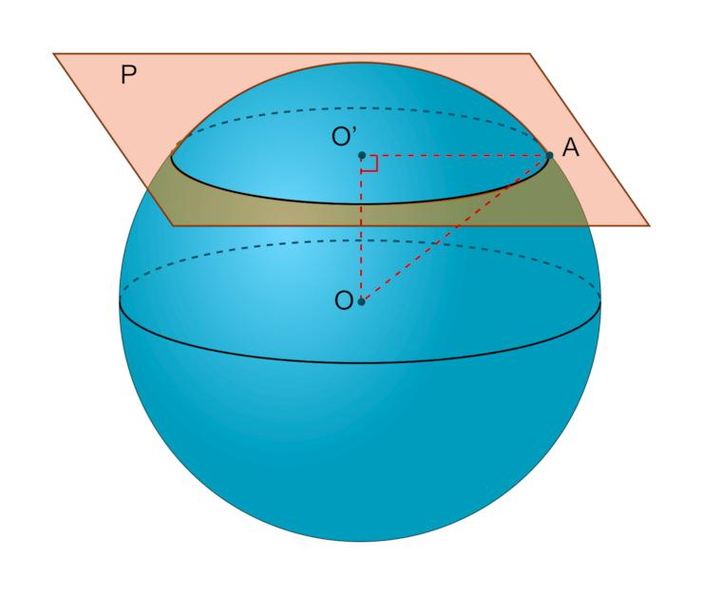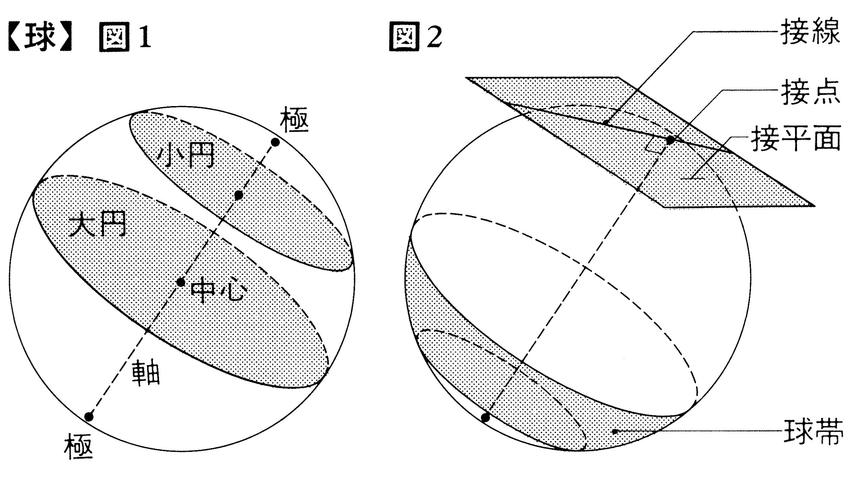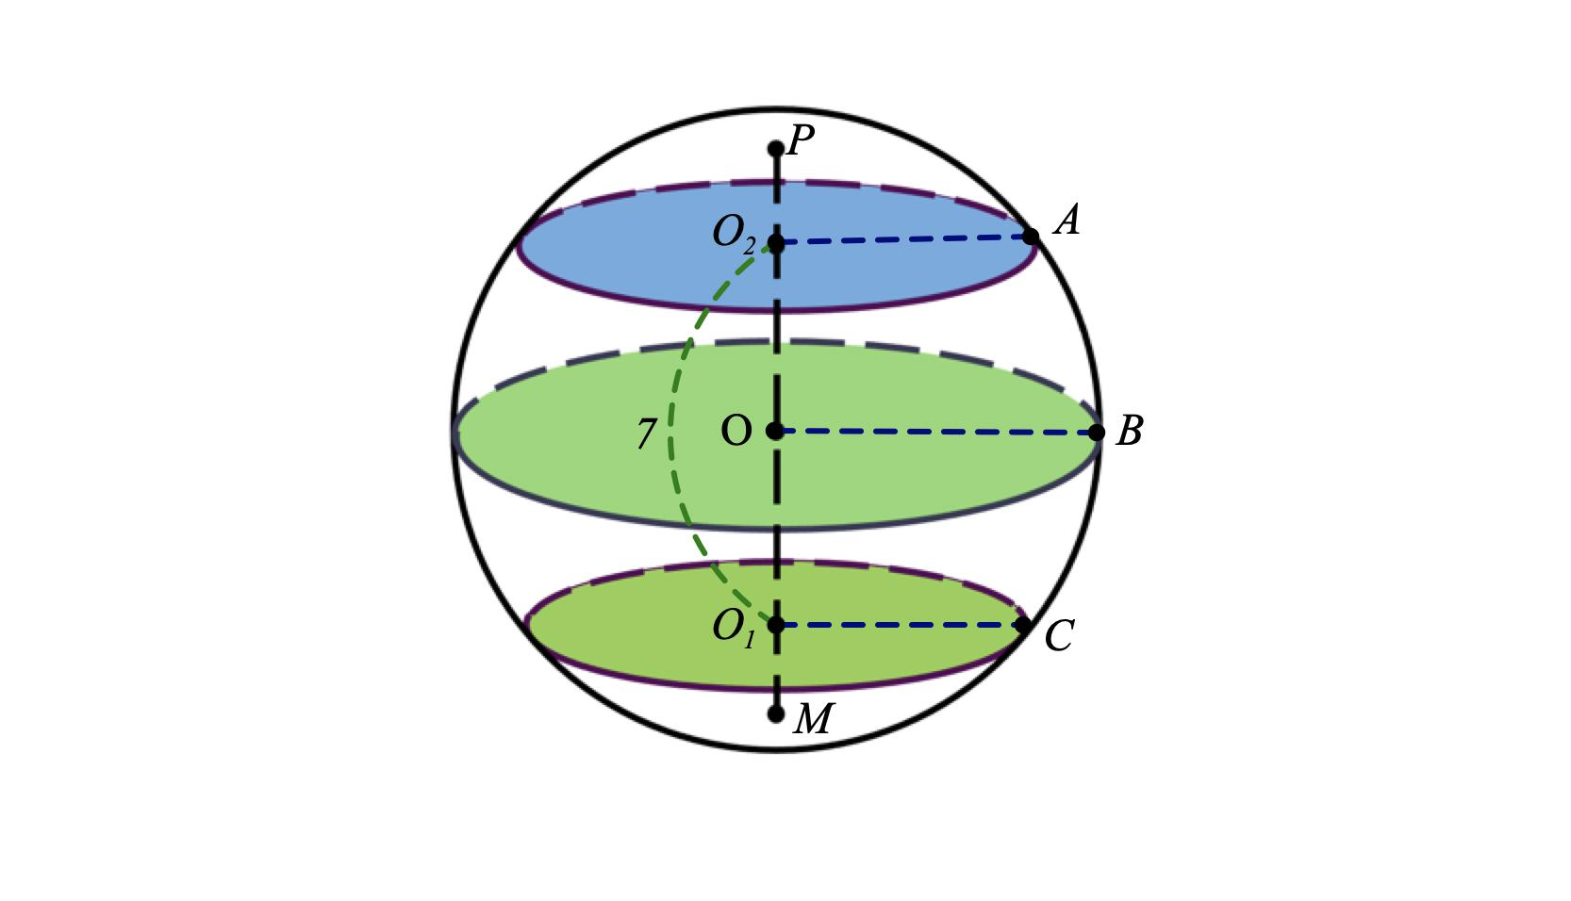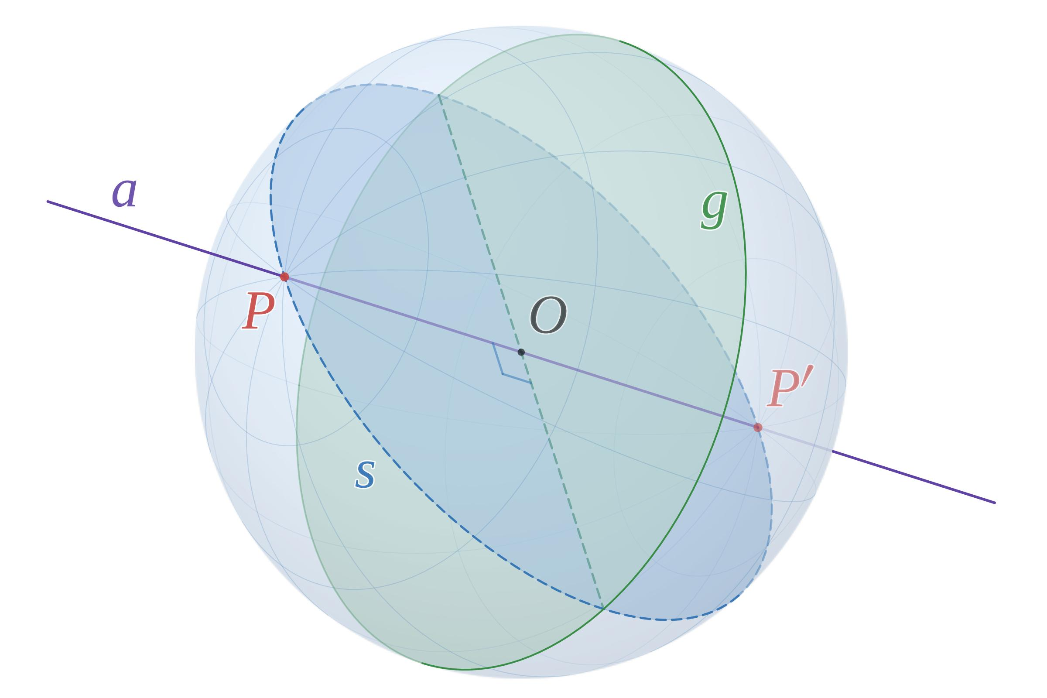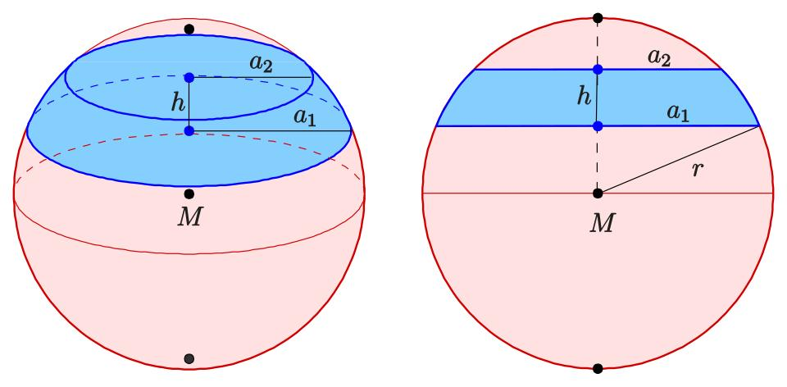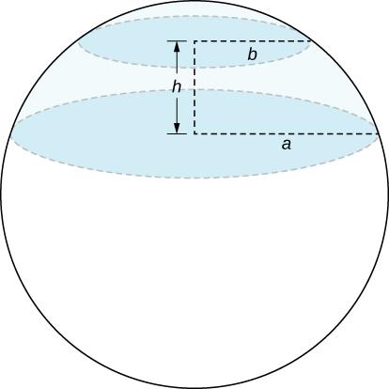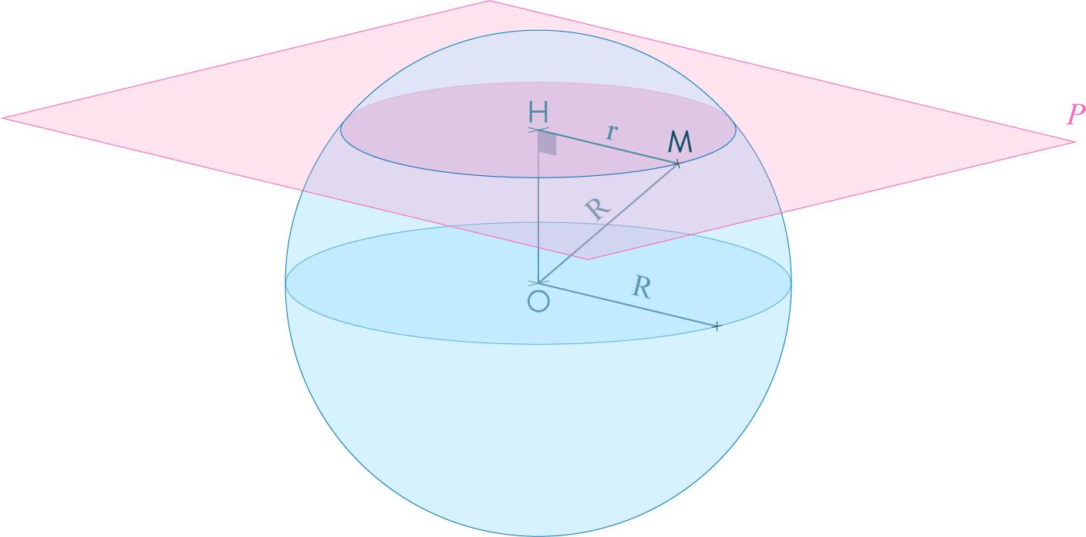

Great Circle
# Source: AI Source: Provided by: [Data Path: Persons Table -> ID Column: 1, Name_En Column: Motasem Essam] -> From: [ChatGPT] on [7/25/2026]
A Great Circle is formed when a plane passes through the center of the sphere.
Its radius equals the sphere radius:
$$r_{g}=R$$

Small Circle
# Source: AI Source: Provided by: [Data Path: Persons Table -> ID Column: 1, Name_En Column: Motasem Essam] -> From: [ChatGPT] on [7/25/2026]
A Small Circle is formed when a plane intersects the sphere without passing through its center.
If the distance from the center to the plane is $d$:
$$\boxed{r_{s}=\sqrt{R^{2}-d^{2}}}$$
Where:
- $r_{s}$ = small-circle radius.
- $R$ = sphere radius.
- $d$ = perpendicular distance from the center to the cutting plane.

Tangent Plane
# Source: AI Source: Provided by: [Data Path: Persons Table -> ID Column: 1, Name_En Column: Motasem Essam] -> From: [ChatGPT] on [7/25/2026]
A Tangent Plane touches the sphere at exactly one point.
The perpendicular distance from the center to the tangent plane equals the sphere radius:
$$d=R$$

Comparison Between Spherical Solids
# Source: AI Source: Provided by: [Data Path: Persons Table -> ID Column: 1, Name_En Column: Motasem Essam] -> From: [ChatGPT] on [7/25/2026]
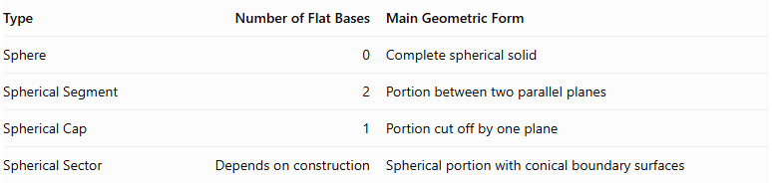
Type | Number of Flat Bases | Main Geometric Form
Sphere | 0 | Complete spherical solid
Spherical Segment | 2 | Portion between two parallel planes
Spherical Cap | 1 | Portion cut off by one plane
Spherical Sector | Depends on construction | Spherical portion with conical boundary surfaces

Applications
# Source: AI Source: Provided by: [Data Path: Persons Table -> ID Column: 1, Name_En Column: Motasem Essam] -> From: [ChatGPT] on [7/25/2026]
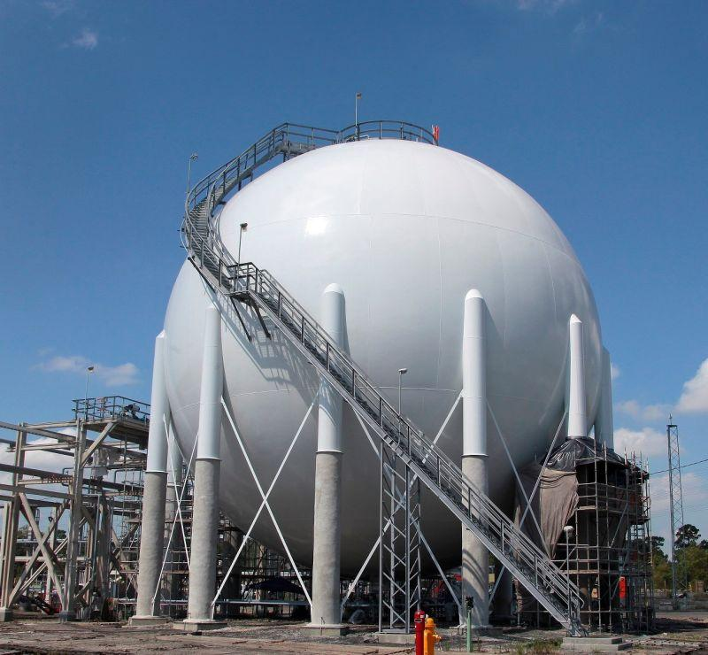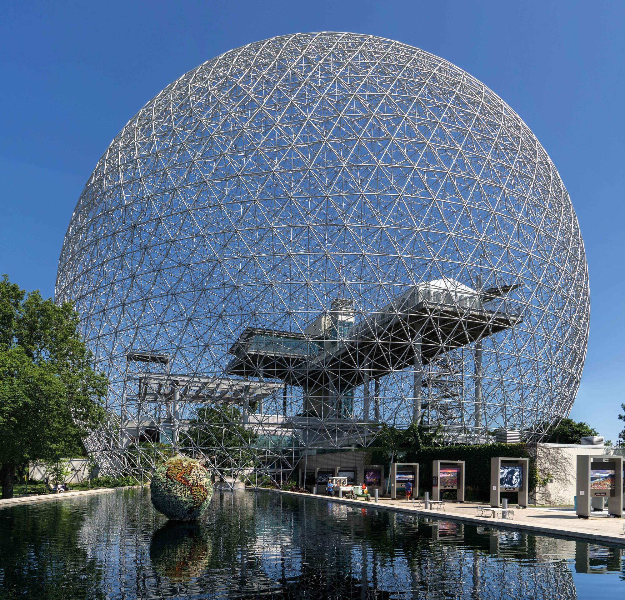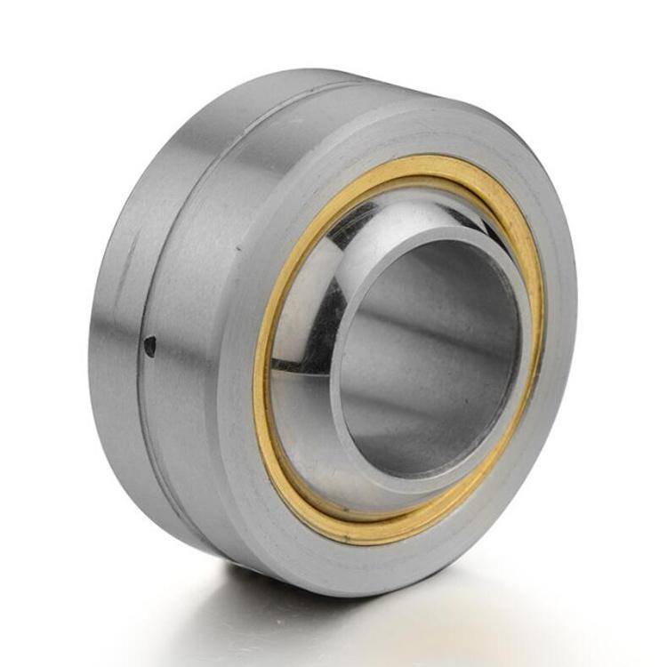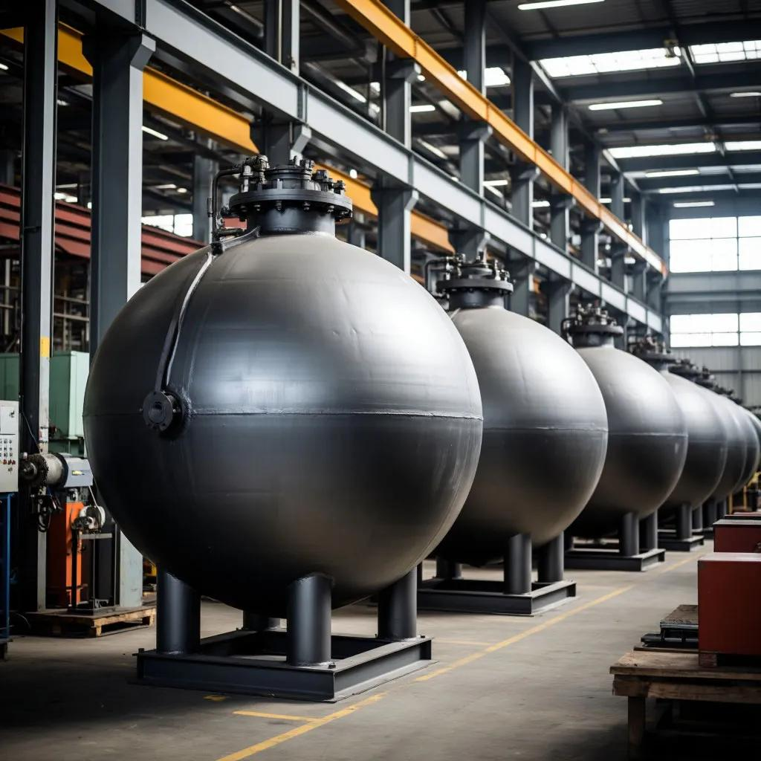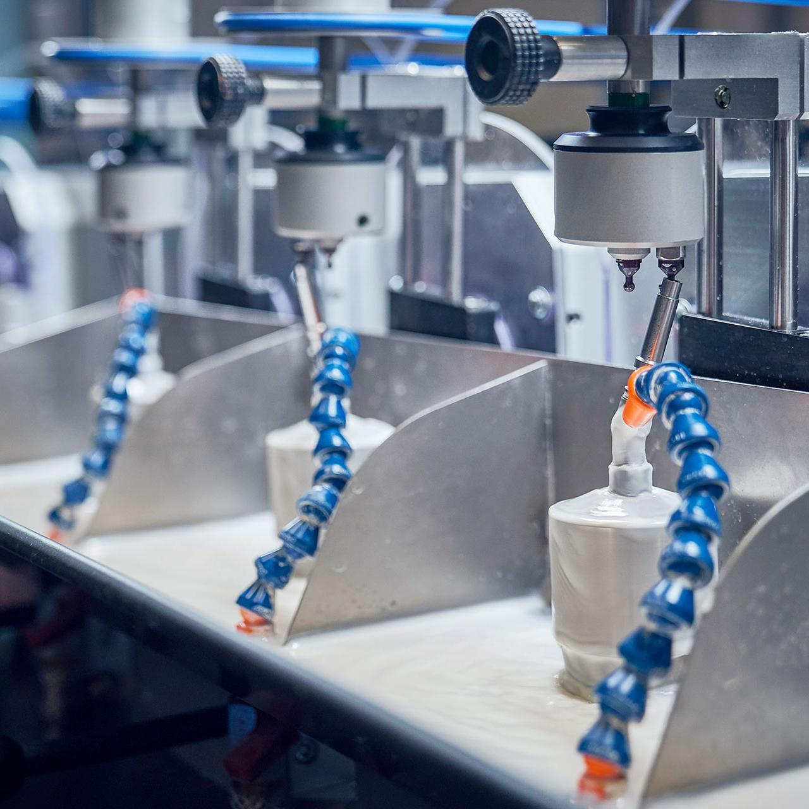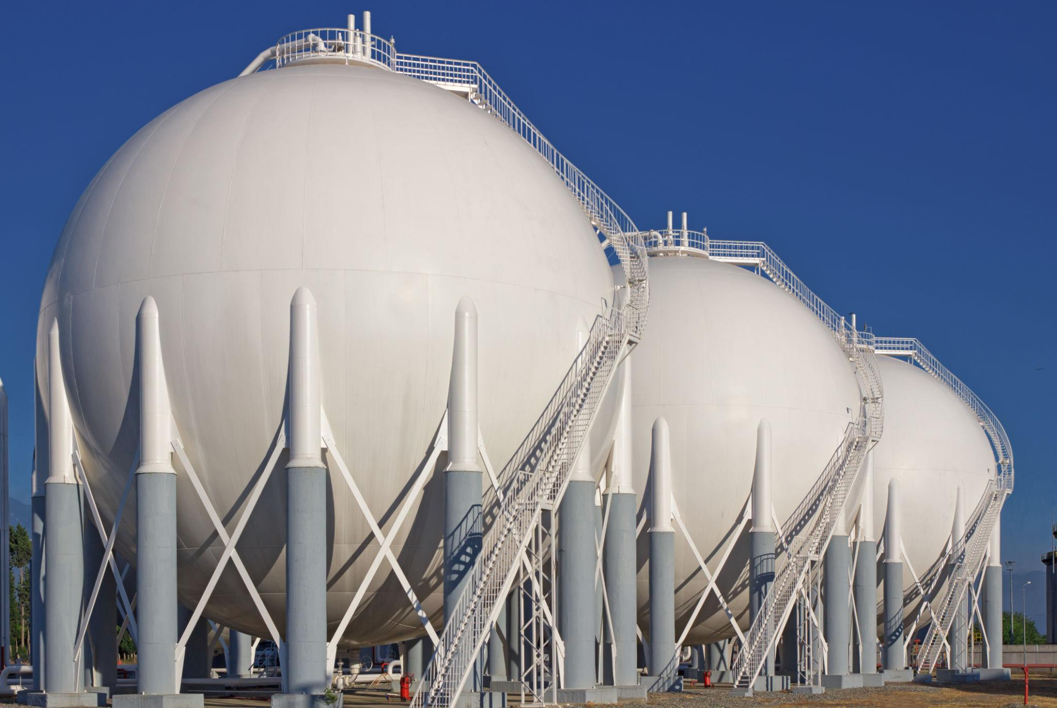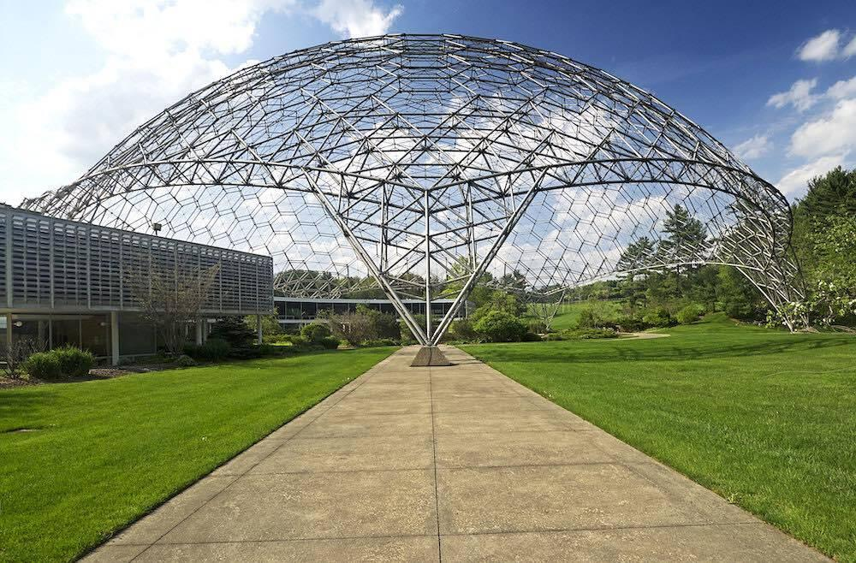
Spherical solids are used in:
- Mechanical Engineering: Ball bearings, spherical joints, and mechanical components.
- Architecture: Domes, spherical structures, and geodesic buildings.
- Industrial Engineering: Spherical storage tanks and pressure vessels.
- Optics: Spherical lenses, mirrors, and optical components.
- Aerospace Engineering: Spherical tanks and specialized pressure containers.
- Construction: Spherical concrete structures and architectural elements.
- Manufacturing: Balls, spherical containers, and precision spherical components.

Comparison Between Cylindrical, Conical, and Spherical Solids of Revolution
# Source: AI Source: Provided by: [Data Path: Persons Table -> ID Column: 1, Name_En Column: Motasem Essam] -> From: [ChatGPT] on [7/25/2026]
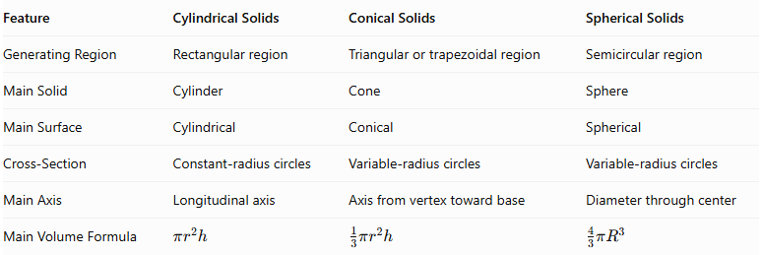
Feature | Cylindrical Solids | Conical Solids | Spherical Solids
Generating Region | Rectangular region | Triangular or trapezoidal region | Semicircular region
Main Solid | Cylinder | Cone | Sphere
Main Surface | Cylindrical | Conical | Spherical
Cross-Section | Constant-radius circles | Variable-radius circles | Variable-radius circles
Main Axis | Longitudinal axis | Axis from vertex toward base | Diameter through center
Main Volume Formula | $$πr^{2}h$$ | $$\frac{1}{3}πr^{2}h$$ | $$\frac{4}{3}πR^{3}$$

Main Classification
# Source: AI Source: Provided by: [Data Path: Persons Table -> ID Column: 1, Name_En Column: Motasem Essam] -> From: [ChatGPT] on [7/25/2026]
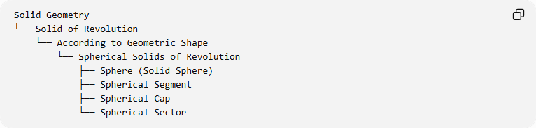
Solid Geometry
└── Solid of Revolution
└── According to Geometric Shape
└── Spherical Solids of Revolution
├── Sphere (Solid Sphere)
├── Spherical Segment
├── Spherical Cap
└── Spherical Sector

Key Points
# Source: AI Source: Provided by: [Data Path: Persons Table -> ID Column: 1, Name_En Column: Motasem Essam] -> From: [ChatGPT] on [7/25/2026]
- Spherical solids are generated by rotating suitable circular regions around an axis.
- Rotating a semicircular region around its diameter generates a sphere.
- The sphere has a constant radius measured from its center to every point on its surface.
- A spherical segment is bounded by two parallel planes.
- A spherical cap is bounded by one cutting plane and a spherical surface.
- A spherical sector includes conical boundary surfaces and a spherical zone.
- Cross-sections through the center produce great circles.
- Cross-sections away from the center produce small circles.
- The sphere has no flat faces, edges, or vertices.

Conclusion
# Source: AI Source: Provided by: [Data Path: Persons Table -> ID Column: 1, Name_En Column: Motasem Essam] -> From: [ChatGPT] on [7/25/2026]
Spherical Solids of Revolution are three-dimensional solids generated by rotating circular or semicircular regions around suitable axes. Their principal forms include the sphere, spherical segment, spherical cap, and spherical sector. They are important in solid geometry because they demonstrate how rotational movement produces spherical surfaces and volumes, with applications in engineering, architecture, manufacturing, and mathematical modeling.

